UML USE CASE MODELING

ONLINE GROCERY STORE SYSTEM

1. Introduction
The Online Grocery Store System is an online platform that allows customers to browse grocery products, add products to a cart, place orders, make payments, and track deliveries.
The system also provides administrative features for managing products, users, orders, categories, offers, and reports. Delivery Partners can view assigned orders and update their delivery status.
The Use Case Diagram represents the interaction between different users and the Online Grocery Store System.

2. Use Case Diagram
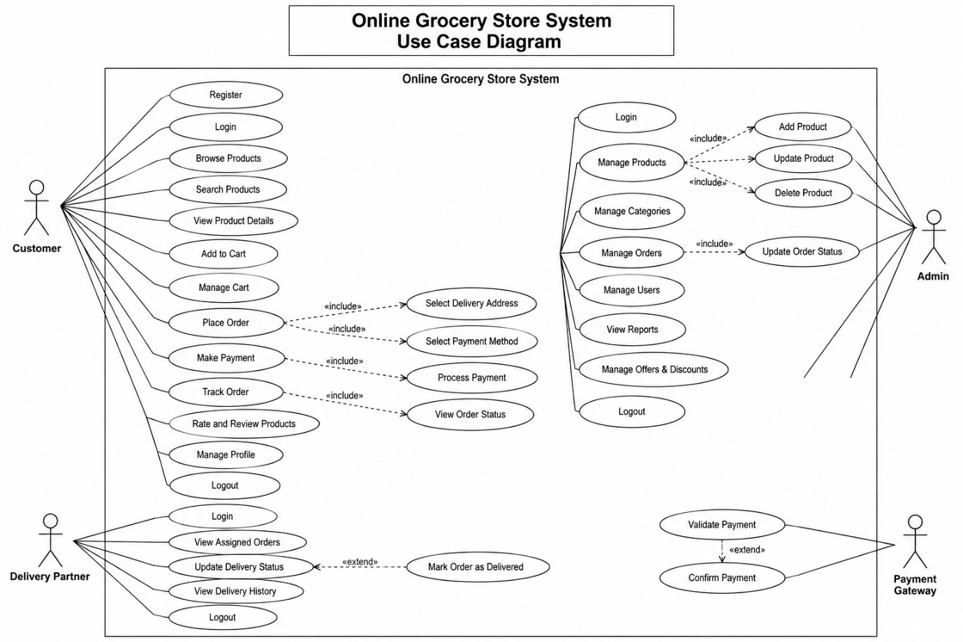
Figure 1: Use Case Diagram – Online Grocery Store System

3. What is a Use Case?
A Use Case represents a specific function or service provided by a system to an actor.
For example:
- Browse Products
- Add to Cart
- Place Order
- Make Payment
- Track Order
- Manage Products
Use cases are represented by oval shapes in UML.

4. Actors
An Actor is a person or external system that interacts with the software.
The Online Grocery Store System has four main actors:

Customer
The Customer can:
- Register/Login
- Browse and search products
- View product details
- Add and manage cart
- Place orders
- Make payments
- Track orders
- Rate and review products

Admin
The Admin manages:
- Products
- Categories
- Orders
- Users
- Offers and discounts
- Reports

Delivery Partner
The Delivery Partner can:
- Login
- View assigned orders
- Update delivery status
- Mark orders as delivered
- View delivery history

Payment Gateway
The Payment Gateway is an external system used to:
- Validate payments
- Confirm payment transactions

5. UML Relationships Used

Association
A solid line represents an association between an actor and a use case.
Example:
Customer ─── Browse Products
It shows that the Customer can use the Browse Products functionality.

<<include>>
A dashed arrow with <<include>> represents functionality that is required as part of another use case.
Examples:
- Place Order → Select Delivery Address
- Place Order → Select Payment Method
- Make Payment → Process Payment
- Manage Products → Add/Update/Delete Product

<<extend>>
A dashed arrow with <<extend>> represents optional or additional behavior.
Example:
- Update Delivery Status → Mark Order as Delivered

6. System Boundary
The large rectangle represents the Online Grocery Store System.
It defines the scope of the system and contains all the use cases provided by the application.
Actors such as Customer, Admin, Delivery Partner, and Payment Gateway remain outside the boundary because they interact with the system externally.

7. Summary
The Use Case Diagram provides a high-level view of the Online Grocery Store System. It identifies the main actors, their responsibilities, and the major functionalities of the system.
The diagram uses standard UML notations such as Actors, Use Cases, Associations, <<include>>, <<extend>>, and System Boundary to represent the system requirements clearly.
This model can be used as a foundation for further SDLC activities such as designing Class Diagrams, Sequence Diagrams, Activity Diagrams, and implementing the system.

UML Notations Used
Notation | Meaning
Stick Figure | Actor
Oval | Use Case
Rectangle | System Boundary
Solid Line | Association
Dashed <<include>> | Included Functionality
Dashed <<extend>> | Extended Functionality

